Expected Output Credit Card Fraud Detection
- Flask Server Running Successful
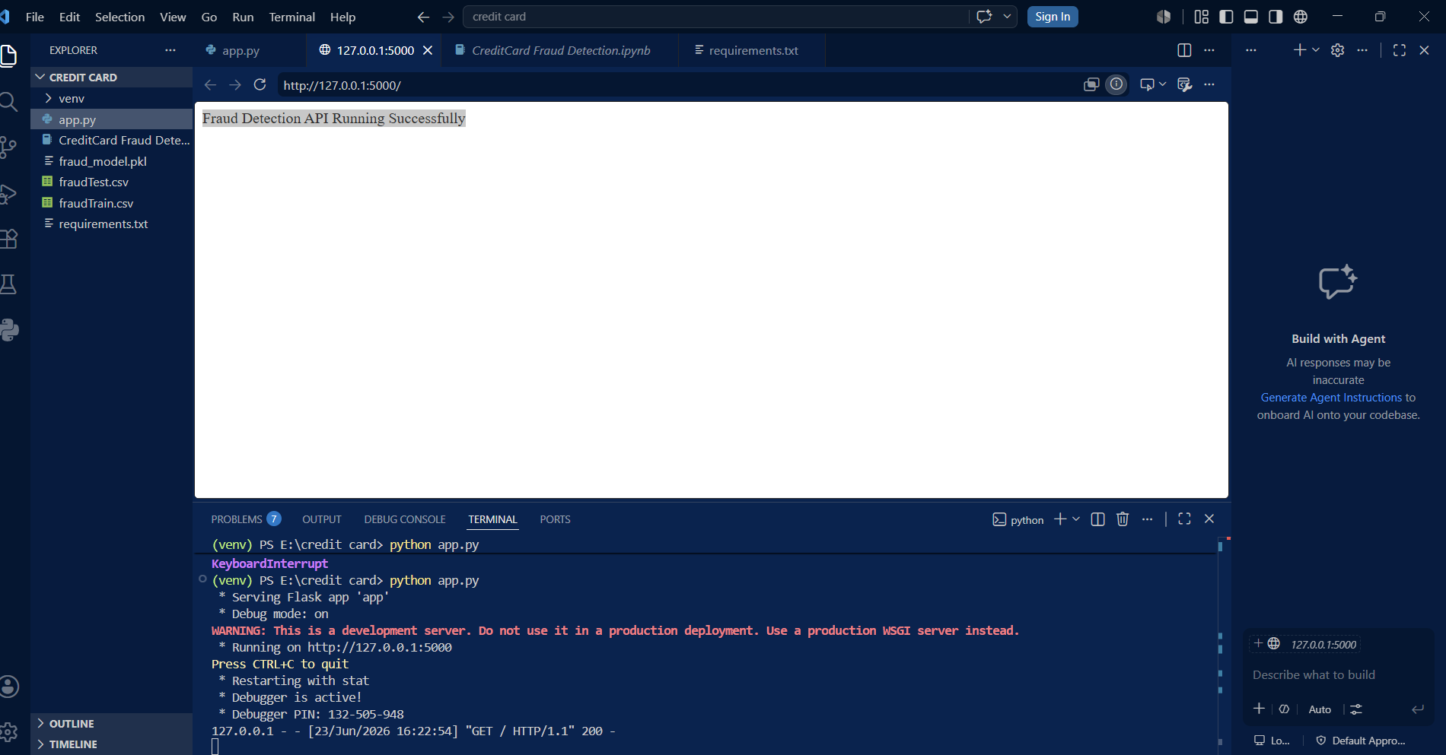

2.Input Validation check with postman
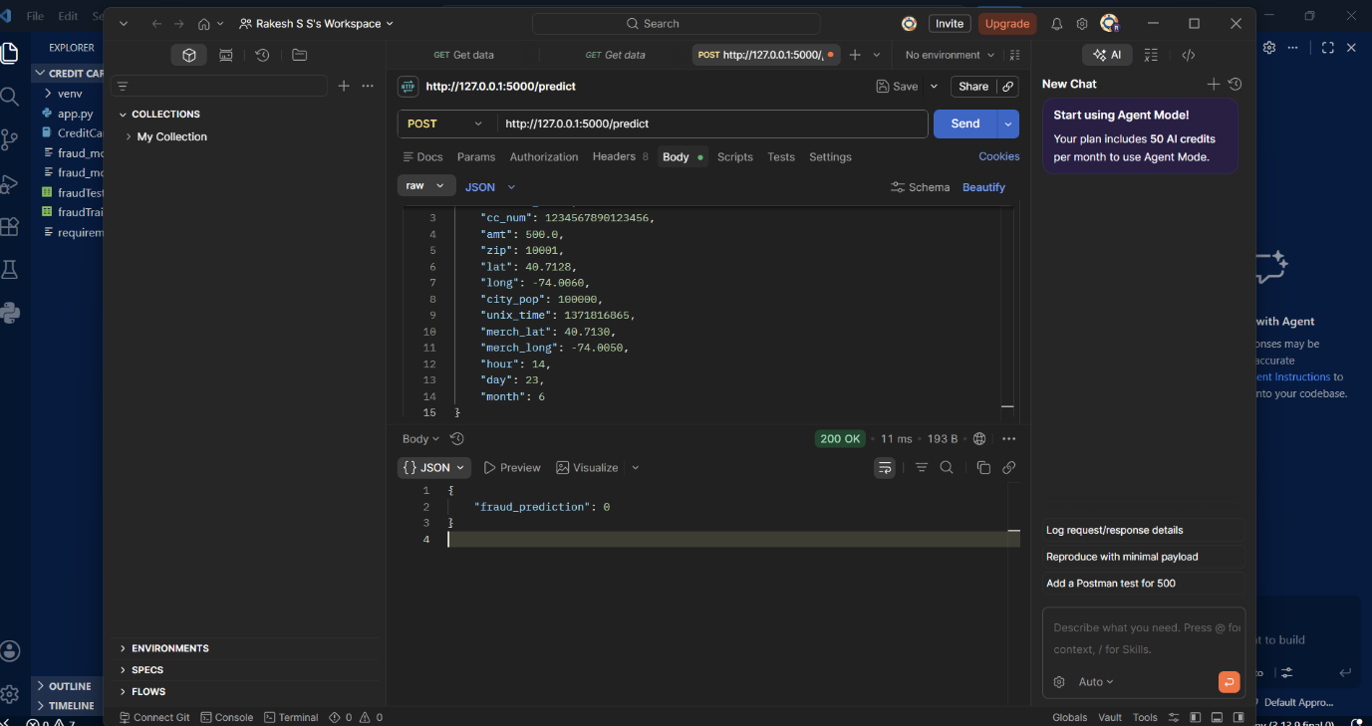

3.Pytest
